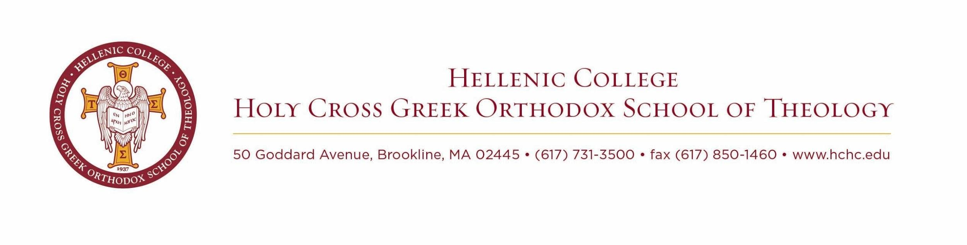
Full-time Position: Events and Operations Assistant
Reports directly to Maliotis Assistant Director and to Maliotis Director
JOB DESCRIPTION
About Maliotis Cultural Center
The Maliotis Cultural Center is a center established by the late Costas and Mary Maliotis to display Greek culture and promote its understanding by producing, sponsoring, and hosting a variety of programs and events. Maliotis operates under Hellenic College Holy Cross Greek Orthodox School of Theology in Brookline, Massachusetts.
Overview
The Maliotis Cultural Center at Hellenic College Holy Cross seeks a candidate for the position of Events and Operations Assistant who will assist MCC in the smooth operations of the building and its functions, and assist in all logistical and administrative tasks to make sure the Cultural Center and its events run smoothly. Through this position, the assistant will gain experience in project and task management, hospitality, and will gain first-hand experience as to the inner workings of a vibrant ministry in the Hellenic and Orthodox worlds.
Key Areas of Responsibility:
- Manage daily activities to ensure operations run smoothly
- Data entry and excel sheet input including shared drive and email lists
- Organize building supplies and inventory
- Oversee facility layout and manage room availability
● Support Maliotis Director and Assistant Director with any and all administrative tasks and events
● Manage catering and transportation logistics for events and meetings
- Write and edit descriptions and press releases, including for website
- Ensure that IT is working properly for classes and presentations
- Ensure safety and health inspections are up-to-date
- Create and manage expense and credit reports for the finance office
- For events, work with the HCHC grounds crew to ensure that venues are properly set up and arranged
- This is a hands-on position. The incumbent must have the flexibility to work evenings and weekends as required
- Other duties and tasks as needed

Education & Work Experience:
- Bachelor's degree required.
- 1-3 years of experience in institutional event planning
- Experience in Greek and Orthodox work environments
- Driving ability
- Proficiency using Canva, Flodesk and Mailchimp, Gmail and other Google applications, as well as online content management forms
- Basic photography, video, audio, and internet skills are required.
- Graphic design skill and flier creation ability.
- Strong knowledge of all MS Office Programs – in particular, Word, Excel and Publisher
Skills and attributes
● Strong command of grammatical English and writing ability
- Punctual, reliable, quick thinking, proactive, and highly organized.
- Able to project track, multi-task, and work collaboratively; Deadline oriented.
- Strong client service and leadership skills; Ethical.
- Friendly, accountable, and eager to learn; Good team player.
- Ability to be tactical and/or strategic.

Language Skills:
- English required; Greek a plus.
Compensation: Commensurate with experience
Interested candidates should submit a cover letter and resume via email to: resumes @hchc.edu

Hellenic College is an equal opportunity employer
A diverse workforce and an inclusive culture is valued

